Webserver

Table of Contents

VPC Creation 2

NextCloud Security Group Creation 3

EFS Storage and S3 bucket creation 4

Step 1: Create EFS Storage 4

Step 2: Create an S3 Bucket 5

Step 3: S3 Policy Generation 6

Step 4: S3 Lifecycle Rule Configuration 7

Creation of EC2 7

Creation of elastic IP 9

Create a Duck DNS domain 9

Configure CloudWatch Monitoring 10

Install NextCloud 10

Configure Nextcloud 13

Backup Setup 13

Log In to Nextcloud 14

Enable External Storage Support 15

Security Scan 15

S3 bucket set up on nextcloud 17

NextCloud New User Creation 19

Create Image & Launch Template 20

Create Launch Template 21

Create AWS Backup Plan 22

Install and Configure Desktop Client 24

Install & Configure Mobile Client 28

# **VPC Creation**



The IPv4 range for this VPC is 10.0.0.0/16



Two Subnets and One S3 Gateway is associated with this VPC Resource Map.



## NextCloud Security Group Creation

There are two security groups created for EC2 and EFS



Inbound rules for EC2 as per requirement



Inbound rules for EFS as per requirement



# **EFS Storage and S3 bucket creation**

Creating EFS Storage and S3 Bucket for NextCloud

Introduction: This document provides step-by-step instructions for setting up Amazon Elastic File System (EFS) storage and an S3 bucket for use with NextCloud.

## Step 1: Create EFS Storage

1. In the AWS (Amazon Web Services) Management Console, navigate to "Elastic File System."
2. Click "Create file system."
3. Choose the previously created VPC from the dropdown.
4. Use the existing security group for access.
5. Complete the EFS setup.



## Step 2: Create an S3 Bucket

1. Navigate to "S3" in the AWS Management Console.
2. Click "Create bucket."
3. Choose the same AWS region as your Nextcloud EC2 instance.
4. Enable bucket versioning.
5. Leave all other settings at their defaults.
6. Click "Create bucket."
7. Confirm that the bucket is NOT public.



## Step 3: S3 Policy Generation

1. In the S3 bucket's properties, navigate to the "Permissions" tab.
2. Click on "Bucket Policy" and use the Policy Generator.
3. Create a policy to allow "LabRole" full access to the bucket.

## Step 4: S3 Lifecycle Rule Configuration



1. In the S3 bucket's properties, navigate to the "Management" tab.
2. Click on "Lifecycle."
3. Create a lifecycle rule that moves ALL files to the intelligent-tiering storage class after 0 days.



# Creation of EC2

Create an EC2 instance with the following specifications:

* + Ubuntu server 22.04LTS;
  + t2.medium;
  + Use previously made VPC and Security group
  + 8GB EBS storage

* Mount the previously created EFS volume into /mnt/efs
  + Enable: automatically mount the file system.
  + Disable: automatically create and attach security groups

* Add the LabInstance role so the instance can connect to S3 and other services

# Creation of elastic IP

Elastic IP created and associated

## Create a Duck DNS domain

Go to <https://www.duckdns.org/>

Elastic IP to point 54.236.100.200

Domain: <https://starsector.duckdns.org>

## Configure CloudWatch Monitoring

Create a new CloudWatch task monitoring NextCloud ec2 instance; Done by creating an alarm to check if the instance fails status checks

# Install NextCloud

Login via ssh with the following command:

*ssh -i "C:\Users\adeko\OneDrive - Red River College Polytech\Cloud Infrastructure\phoenix.pem" ubuntu@54.236.100.200*

\

Perform updates using the following code:

* *sudo apt update*
* *sudo apt dist-upgrade*

Install docker.io from repositories using the command: *sudo apt install docker.io*

Create a folder called docker folder In your EFS mount and other necessary folders:

* + */mnt/efs/docker*
  + */mnt/efs/docker/nextcloud_aio_apache*
  + */mnt/efs/docker/nextcloud_aio_collabora_fonts*
  + */mnt/efs/docker/nextcloud_aio_database*
  + */mnt/efs/docker/nextcloud_aio_database_dump*
  + */mnt/efs/docker/nextcloud_aio_mastercontainer*
  + */mnt/efs/docker/nextcloud_aio_nextcloud*
  + */mnt/efs/docker/nextcloud_aio_nextcloud_data*
  + */mnt/efs/docker/nextcloud_aio_redis*
  + */mnt/efs/backup*

Manually ADD docker volumes for each of the folders created

* *sudo docker volume create --driver local --name nextcloud_aio_apache -o device=/mnt/efs/docker/nextcloud_aio_apache -o type=none -o o=bind*
* *sudo docker volume create --driver local --name nextcloud_aio_collabora_fonts -o device=/mnt/efs/docker/nextcloud_aio_collabora_fonts -o type=none -o o=bind*
* *sudo docker volume create --driver local --name nextcloud_aio_database -o device=/mnt/efs/docker/nextcloud_aio_database -o type=none -o o=bind*
* *sudo docker volume create --driver local --name nextcloud_aio_database_dump -o device=/mnt/efs/docker/nextcloud_aio_database_dump -o type=none -o o=bind*
* *sudo docker volume create --driver local --name nextcloud_aio_mastercontainer -o device=/mnt/efs/docker/nextcloud_aio_mastercontainer -o type=none -o o=bind*
* *sudo docker volume create --driver local --name nextcloud_aio_nextcloud -o device=/mnt/efs/docker/nextcloud_aio_nextcloud -o type=none -o o=bind*
* *sudo docker volume create --driver local --name nextcloud_aio_nextcloud_data -o device=/mnt/efs/docker/nextcloud_aio_nextcloud_data -o type=none -o o=bind*
* *sudo docker volume create --driver local --name nextcloud_aio_redis -o device=/mnt/efs/docker/nextcloud_aio_redis -o type=none -o o=bind*
* *sudo docker volume create --driver local --name backup -o device=/mnt/efs/backup -o type=none -o o=bind*

Run the command to install NextCloud

# For Linux and without a web server or reverse proxy (like Apache, Nginx, Cloudflare Tunnel and else) already in place:

sudo docker run \

--init \

--sig-proxy=false \

--name nextcloud-aio-mastercontainer \

--restart always \

--publish 80:80 \

--publish 8080:8080 \

--publish 8443:8443 \

--volume nextcloud_aio_mastercontainer:/mnt/docker-aio-config \

--volume /var/run/docker.sock:/var/run/docker.sock:ro \

nextcloud/all-in-one:latest

You should be able to open browser and put in <https://elasticIP:8080>

Allows you to set up nextcloud.

Note the password

# Configure Nextcloud

Make sure collabora is checked and others are unchecked

Set your backup location as /mnt/efs/backup NOTE: This should have been created previously

Change the time zone: America/Winnipeg

Wait until all the containers are GREEN Note: Might take a while

Note the Admin username and password, NOTE: do not lose this

## Backup Setup

Enter your backup path “***/mnt/efs/backup***” and create a backup; NOTE: this would stop containers do not be alarmed.

Note the backup encryption key;

## Log In to Nextcloud

Click on the link that says open your nextcloud

Then log in with your credentials as seen in the following picture

### Enable External Storage Support

This done by clicking on your profile icon and selecting Apps

In the list you should see the external storage support with an option to enable.



### Security Scan

Click on your profile and select Administration Settings

Click the security scan link which will take you to:

Put In your domain to check the security for the server

The Scan should show like so:

### S3 bucket set up on nextcloud

Add Shared Folder “Data” to the external storage settings

This should connect to your AWS S3 bucket

Add your bucket name and region, Authentication was set to none.

Go to the Data folder and upload a test file;

Verify that it has been added to your S3 bucket

## NextCloud New User Creation

Create a new User by going to the user tab and selecting the option new user



Fill the information for a new test user

# Create Image & Launch Template

Create an Amazon Machine Image from the instance

Select the instance -> Actions -> Image and templates -> create image

Hit create Image after filling the information

## Create Launch Template

Select Launch Template from the left side menu -> create launch template

Choose “My AMIs” and then choose the previously created Nextcloud AMI.

* Instance type: t2.medium
* Key pair: choose a previously created one.
* Choose the previously created security group (remove any others).
* Under advanced details:
* Choose the “LabInstanceProfile” under IAM instance profile.

You can use this launch template to quickly launch a new fully operational Nextcloud instance, assuming you setup persistent shared storage. Once it’s running, you just need to point your elastic IP at the new instance and everything should work correctly within a few minutes.

# Create AWS Backup Plan

Search services for AWS backup

-select create a backup plan

Select start with a template and choose Daily-Monthly-1yr-Retention -> create plan

It should ask to assign resources

Select choose an IAM role -> LabRole

Include Specific resources: EBS, EFS, S3

Uncheck all resources and select only your created resources

Select Assign resources

# Install and Configure Desktop Client

Download the NextCloud client from [NextCloud Download page](https://nextcloud.com/download/#install-clients)

Launch and configure with the wizard that pops up

You would need put your nextcloud link that you in a browser in the window below to connect it

You should get a pop up on your desktop client via the browser

Grant Access

Set up file configurations as you see fit

Select choose what to sync -> make sure you uncheck Data folder because its too large, select others

Test by pasting any files on your folder on your computer and check the browser its should sync automatically





# Install & Configure Mobile Client

Download from the Appstore

Put in Server information and log in as a User;

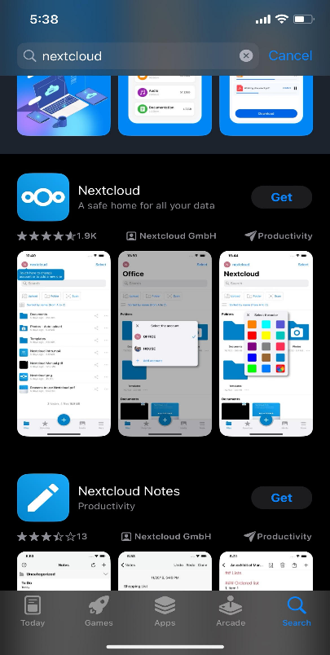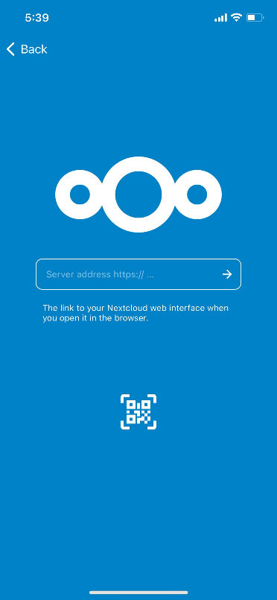

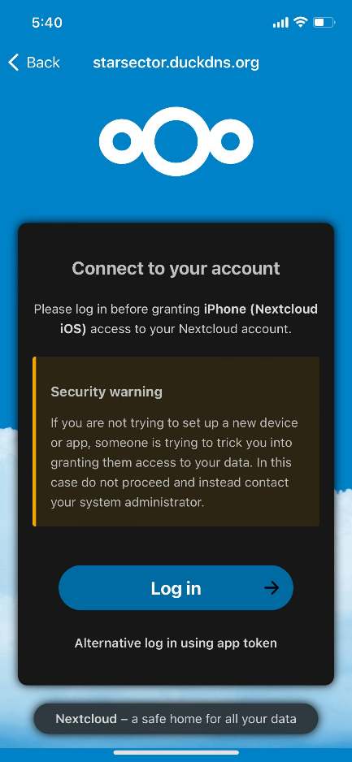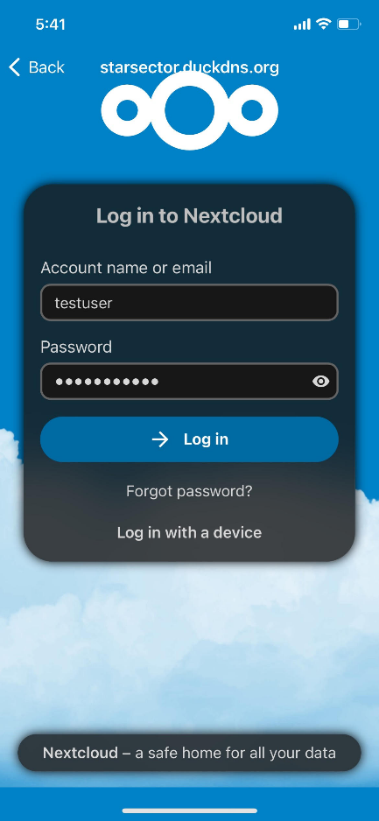

Go to Settings and turn on the auto Upload feature for pictures

Take new picture and check the browser to see if the pictures synced.

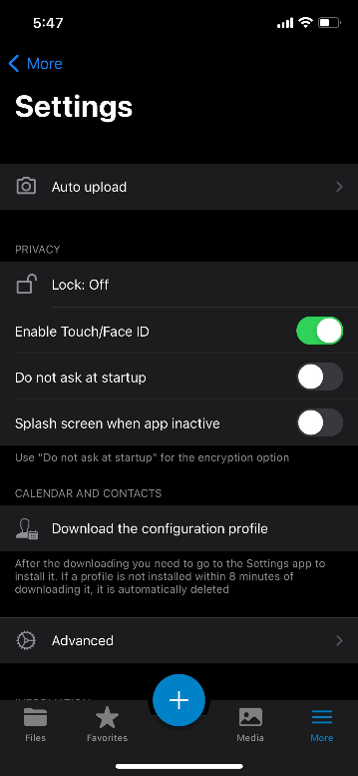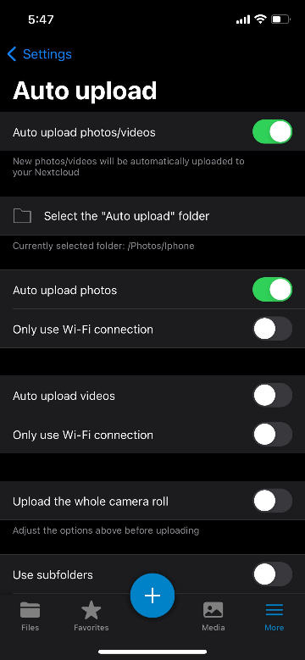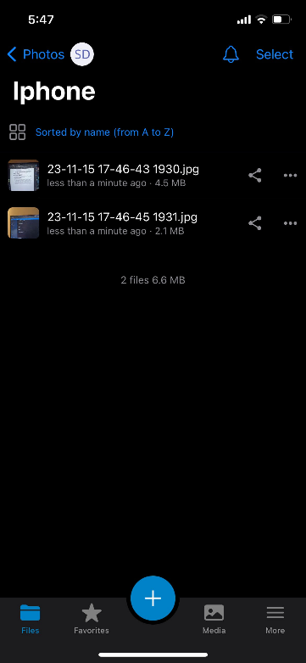

The test should be confirmed with image similar to the one below

